Ashby Aviation Pty Ltd T/A

Building an Agricultural Airstrip

Aerial application is a very efficient way to apply pesticides, herbicides, and fertilizers on your farm. One of the largest benefits of building/restoring an agricultural airstrip is giving yourself the access to efficient cost-effective applications. However, to do this you must ensure you understand your own responsibilities for safety and environment protection. The AAAA’s along with CASA have developed guidelines to help farmers contribute to the safety of pilots, productivity of aircraft and compliance.

Things to consider when putting in a strip……….

Access for vehicles
Rebel Ag Aviation need to be able to get into the strip with a truck carrying our mixing equipment and fuel. You need a good access road that is useable when we may need the strip the most, ie when it has just rained.

Available water
We cannot bring water with us; we use too much of it. You need to be able to supply water to us. One aircraft may need up to 6000L per hour. Here are a few options.

Put a tank at the strip and fill it with your water trailer or a piped supply of water. A 5000 to 10000L tank would suit depending on how fast it refills. This is a good option for regular aircraft users.
Use a water trailer to cart water. We have a tank on our truck to hold one load so you have time to go back for another load (about 20 minutes). This is a good option if you have a big water trailer.

Type of Airstrip
The ideal airstrip is a gravel all weather airstrip that we can use the day after rain. The other end of the scale is a grass field that you run the slasher over when you want to use it.
Consider these ideas.

If you want an all-weather strip then you can offset the cost by using a straight piece of existing gravel road. Many growers these days are setting up their farms to allow all weather access for grain trucks, so all they need to do is make one of these straight for 800m. The road needs to be a little bit wider than normal and away from fences or powerlines. See the diagram below for measurement details
Kick in with a group of neighbours for a good central airstrip.
A dirt strip will dry out quicker if it is properly graded with a positive camber and table drains to help water drain off quickly.
Usually what holds up a strip after rain are a few low spots or puddles. This is a good option if gravel is too expensive.

We will operate out of any flat area that meets our specifications and has been assessed by a pilot or Marcus. See diagram below.

Fertiliser Spreading needs to be done as close as possible due to the large number of loads, so if you are planning a large area of urea spreading it would be worth it just to run the drag bucket over a flat area of paddock and make a temporary airstrip.
As long as it is hard and smooth enough to drive a utility on at 100kph, it should be adequate.

Airstrip dimensions

These are strip dimensions recommended by the Aerial Application Association of Australia LTD. A standard strip will take up about 3 hectares if you allow for the fact that you could grow a crop in the clear areas on the side of the strips. Always discuss with your aerial operator about the specifications for your airstrip as they will be the ones who will undertake a risk assessment and will not operate off it until they deem it to be safe and of standard.

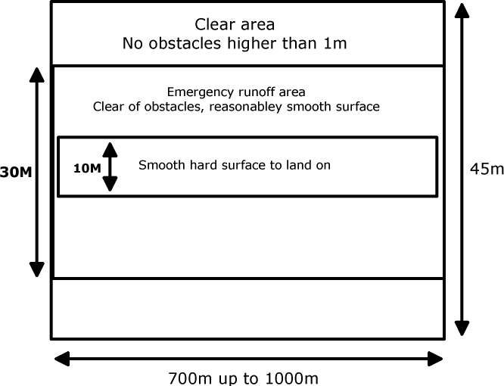

Attached is a pdf of the Safer Strips Brochure by the AAAA’s for your information.

Safer Strips Brochure 2012.pdf

